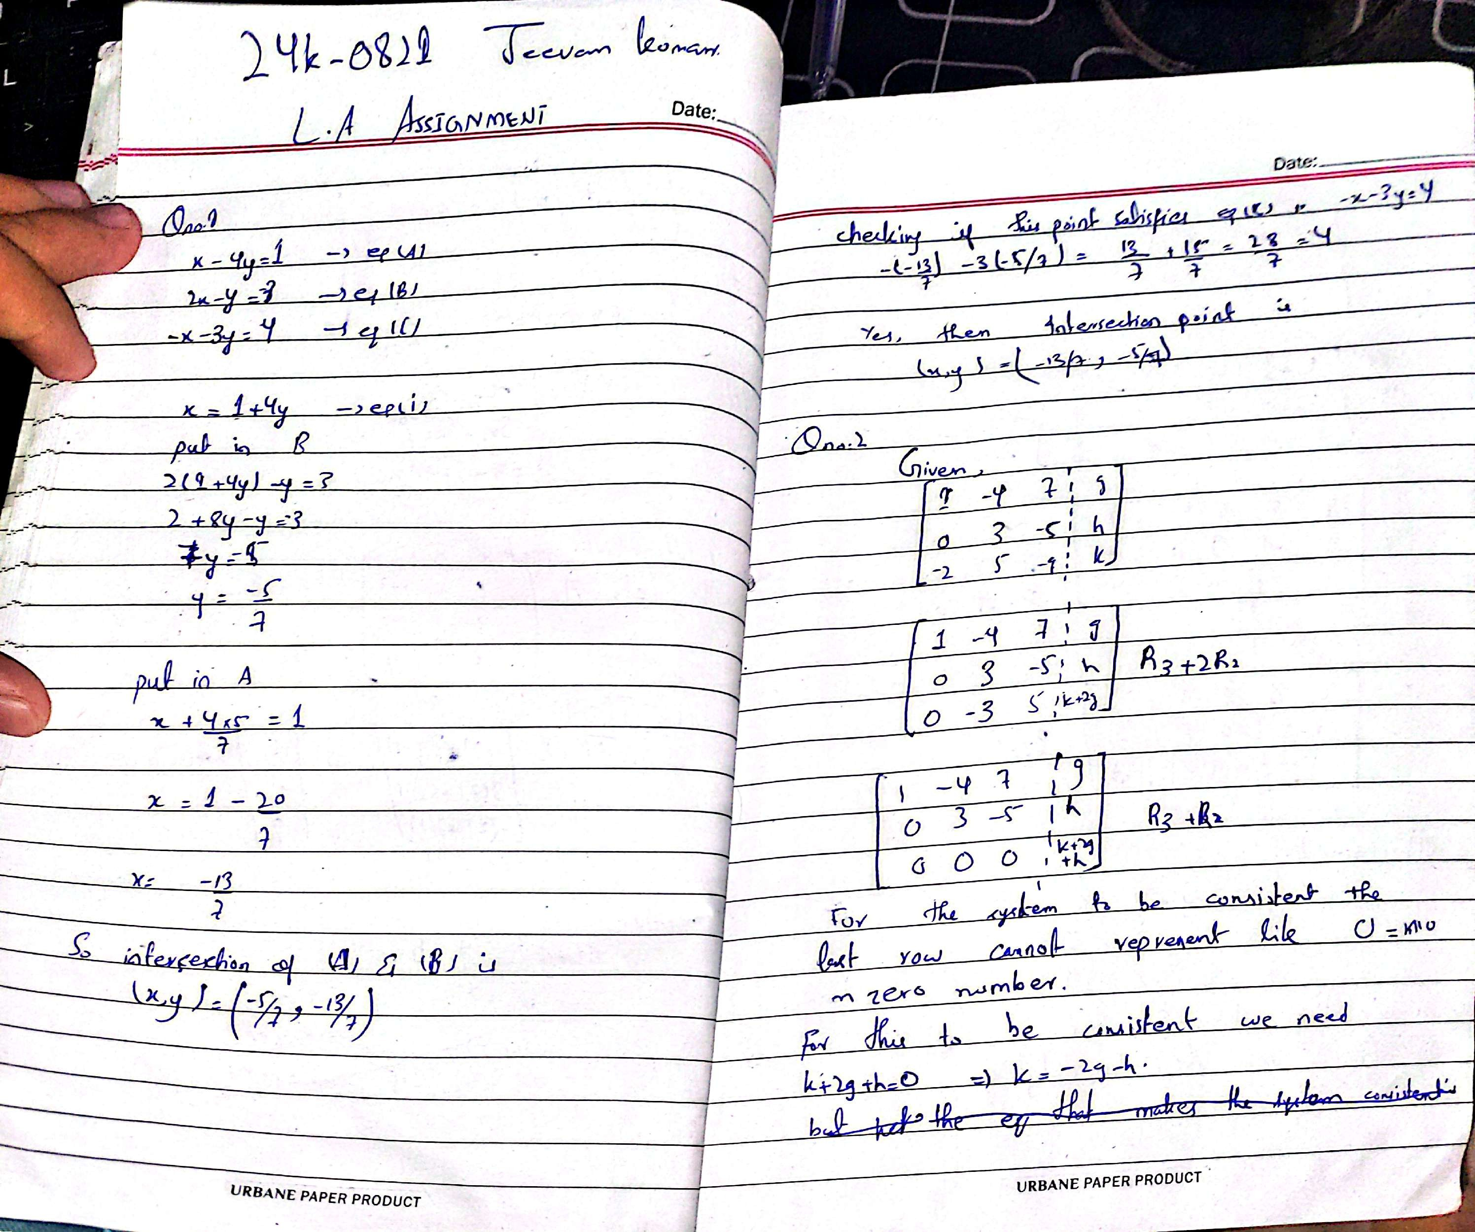

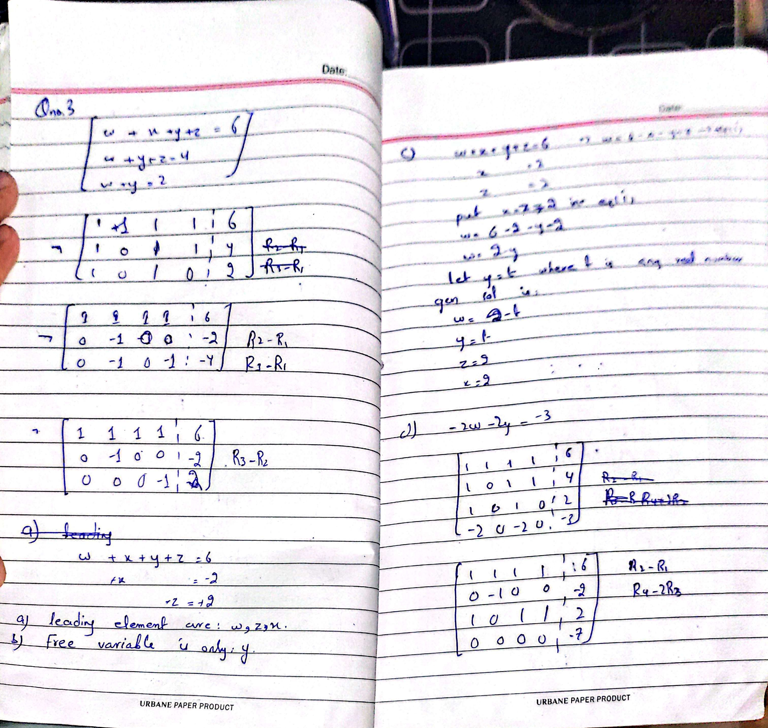

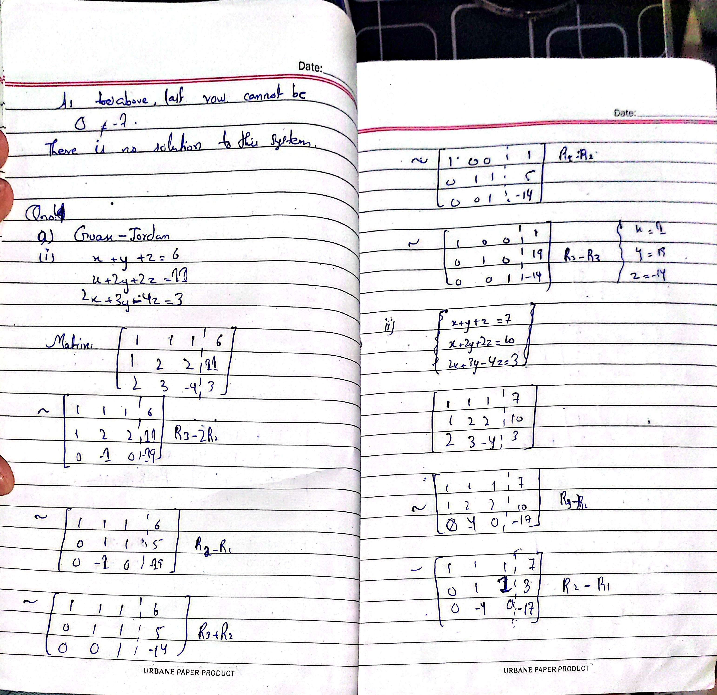

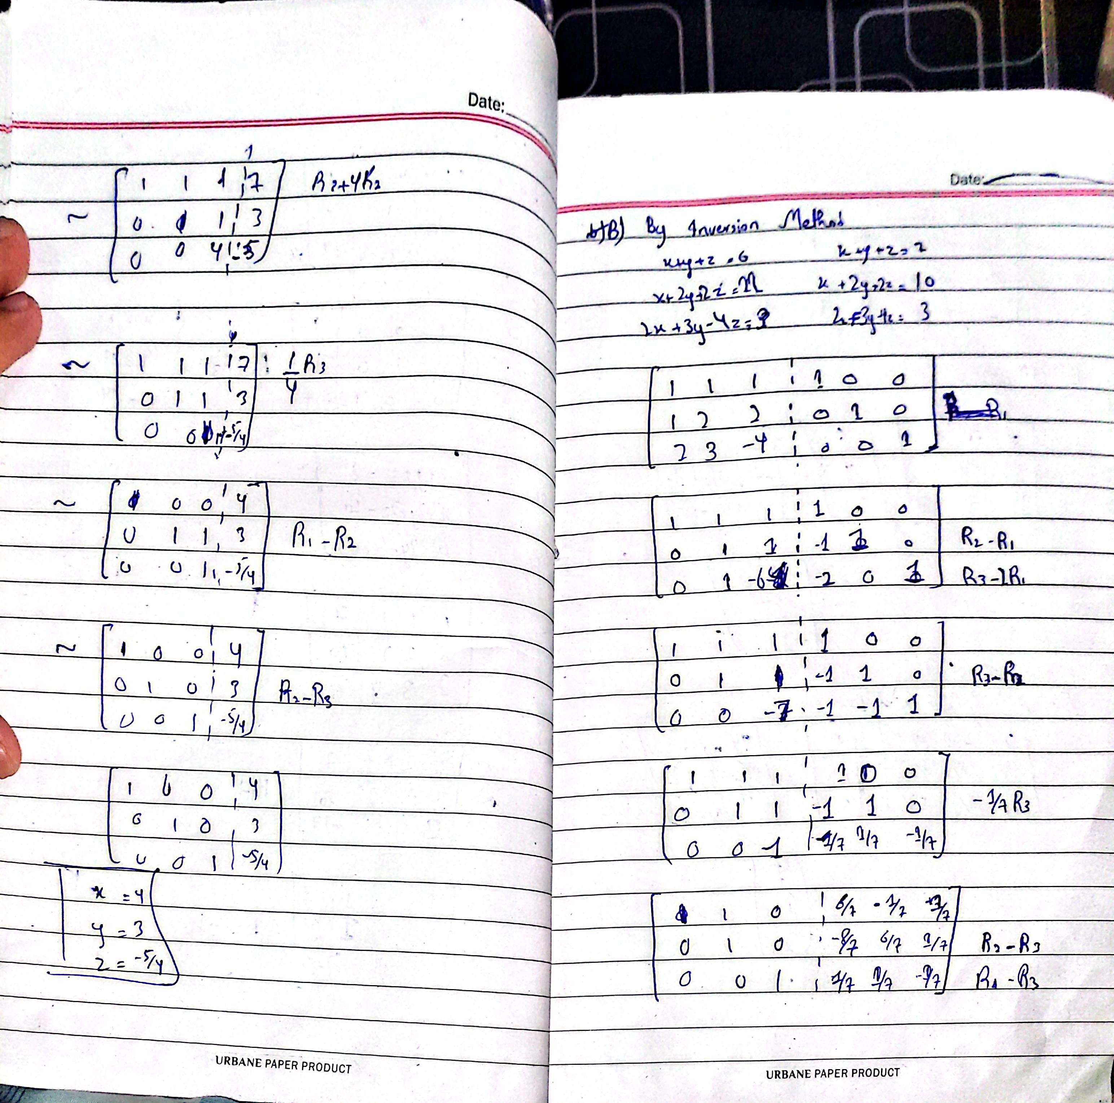

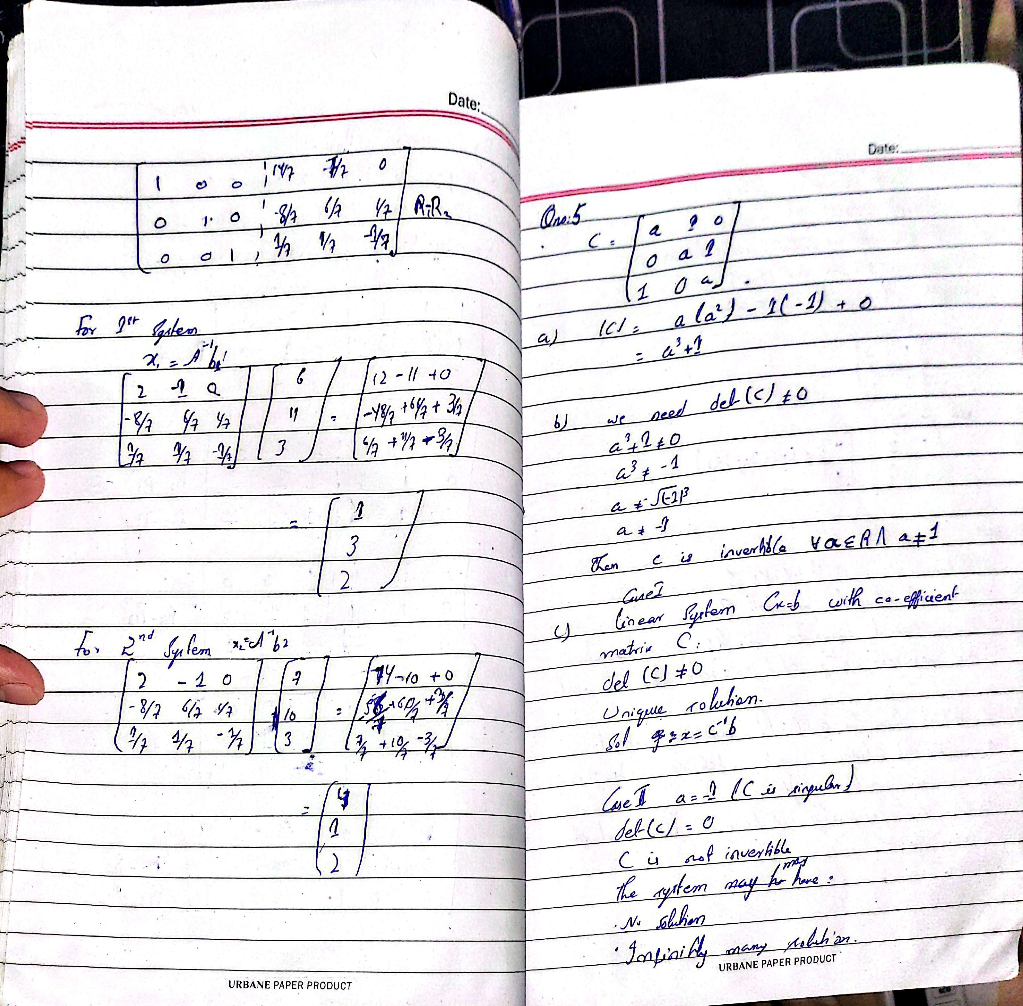

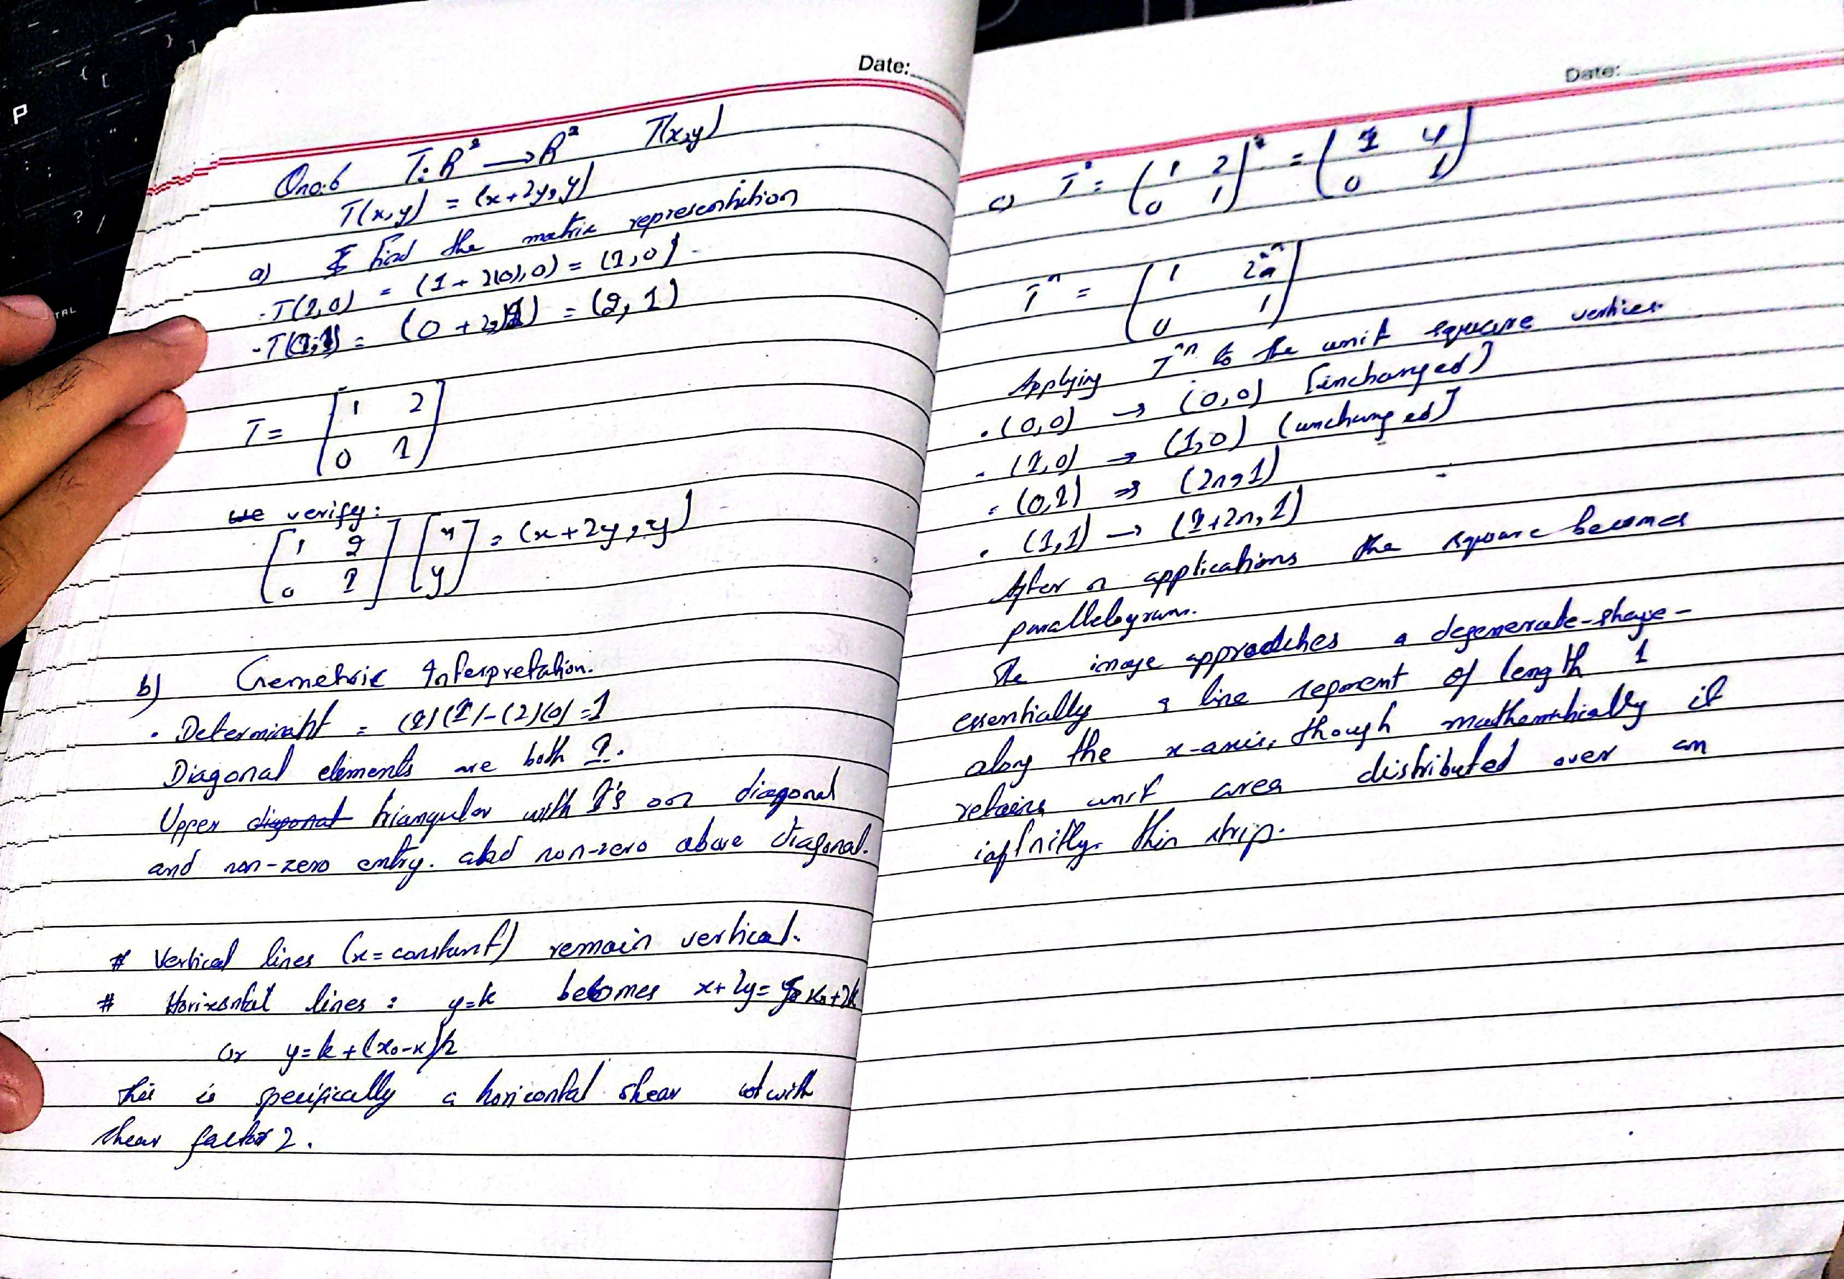

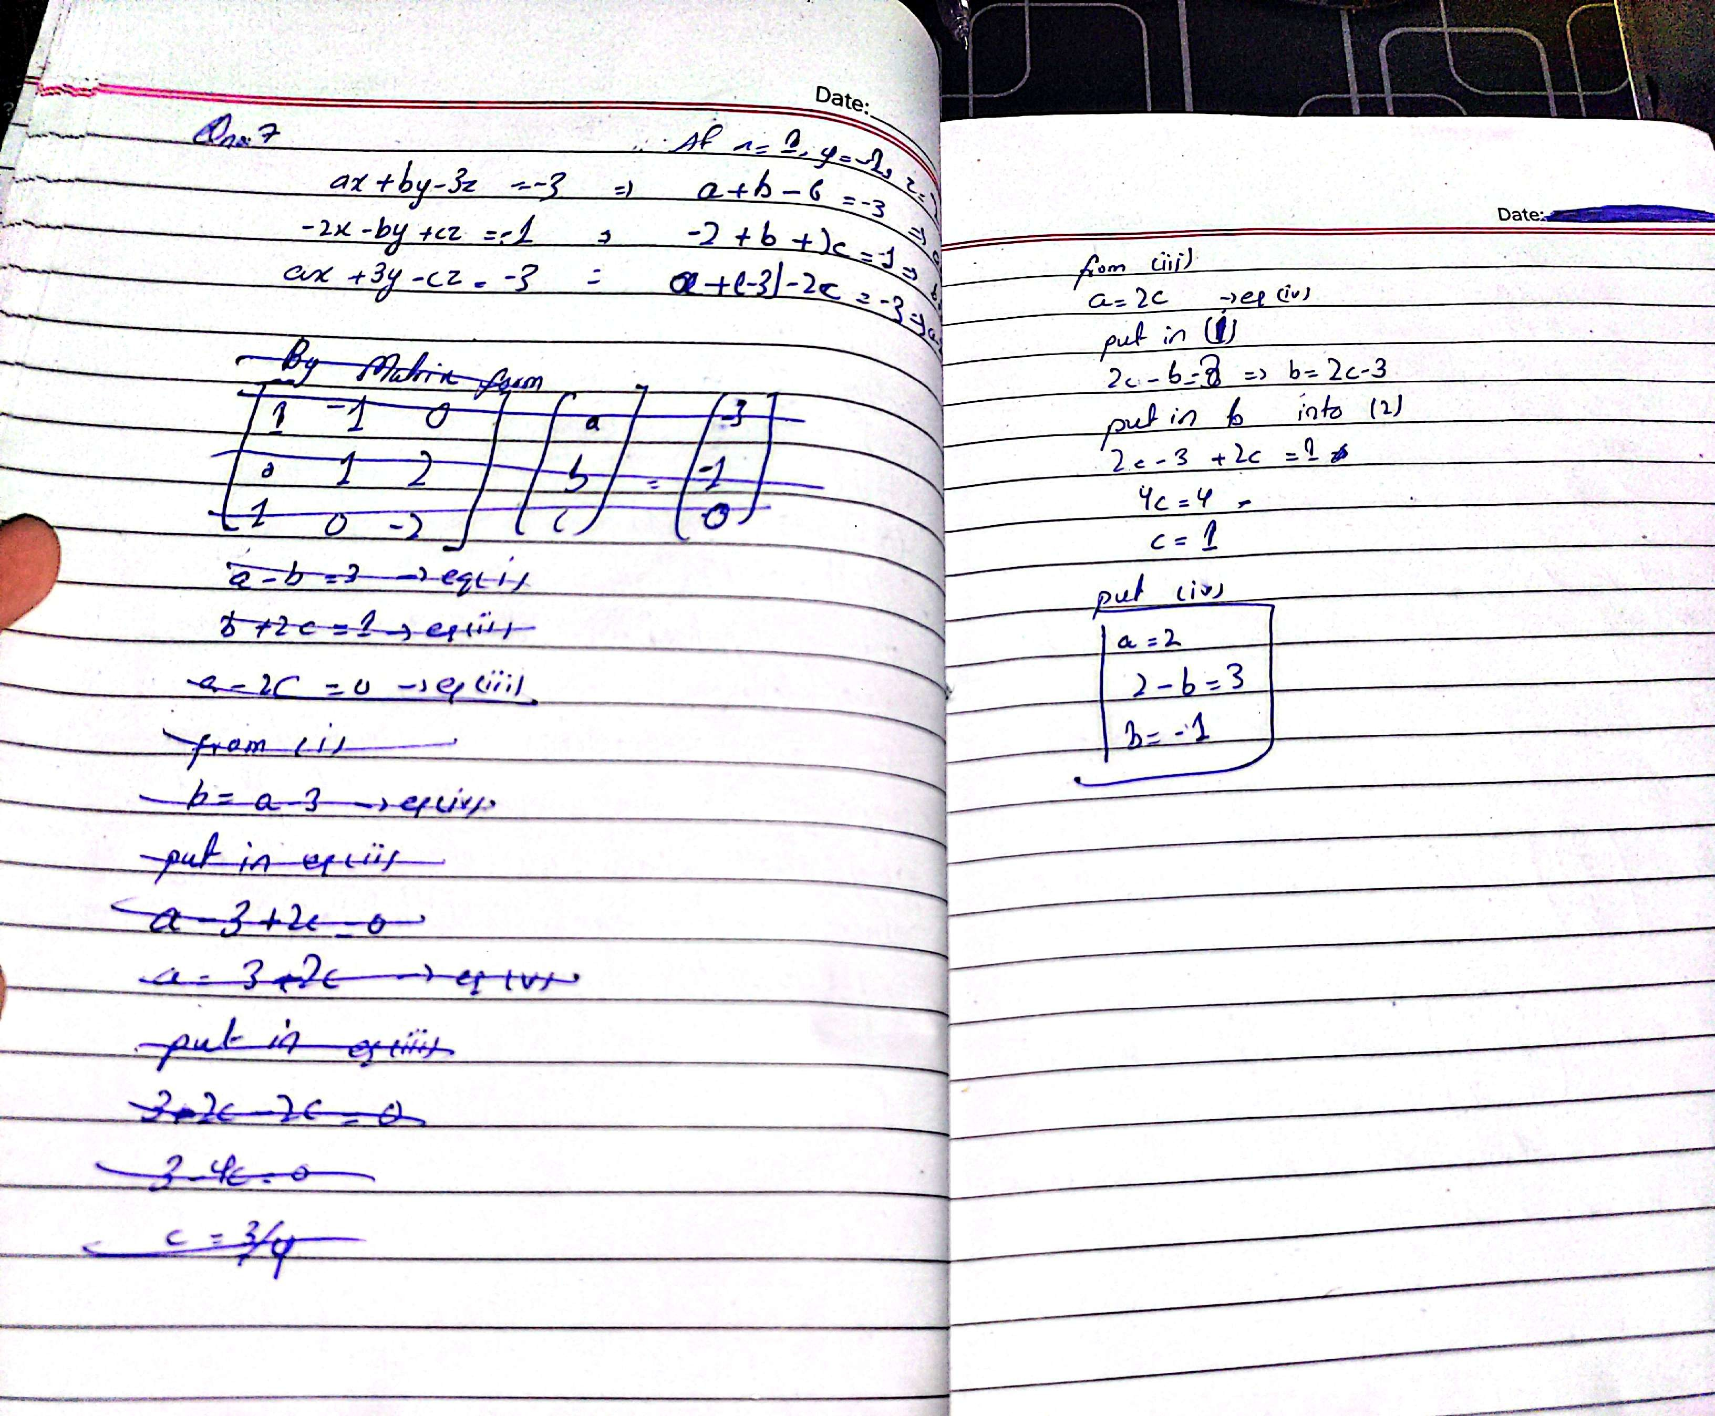

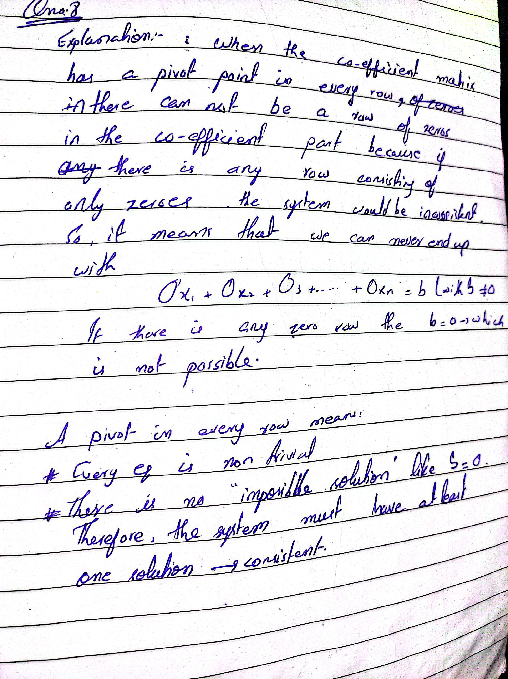[CamScanner](https://v3.camscanner.com/user/download)

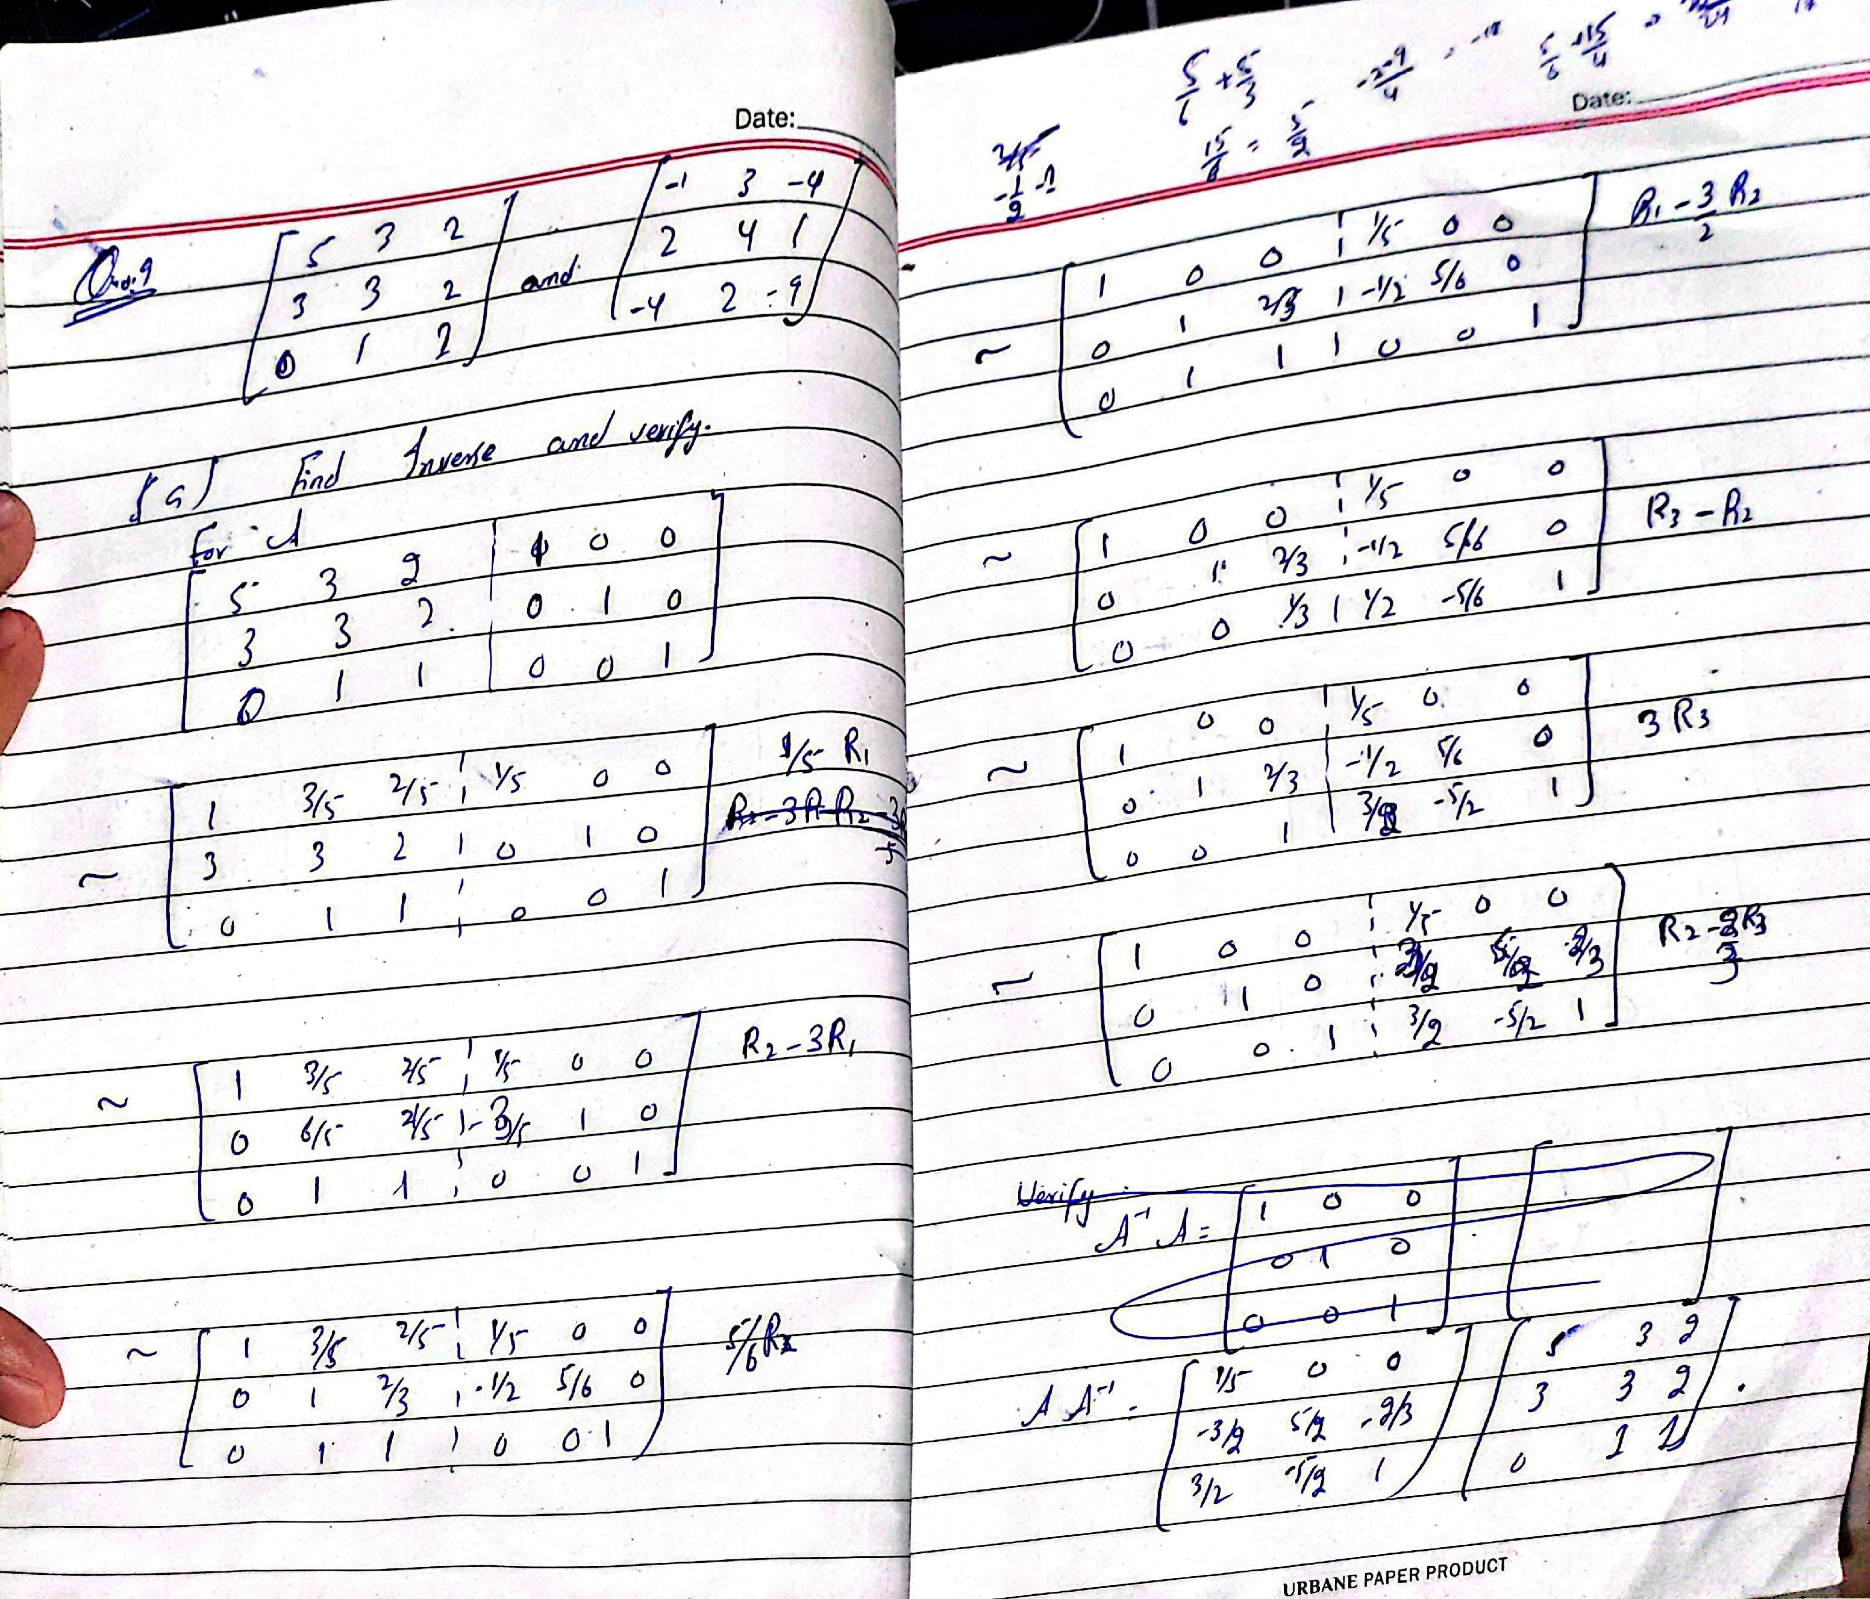

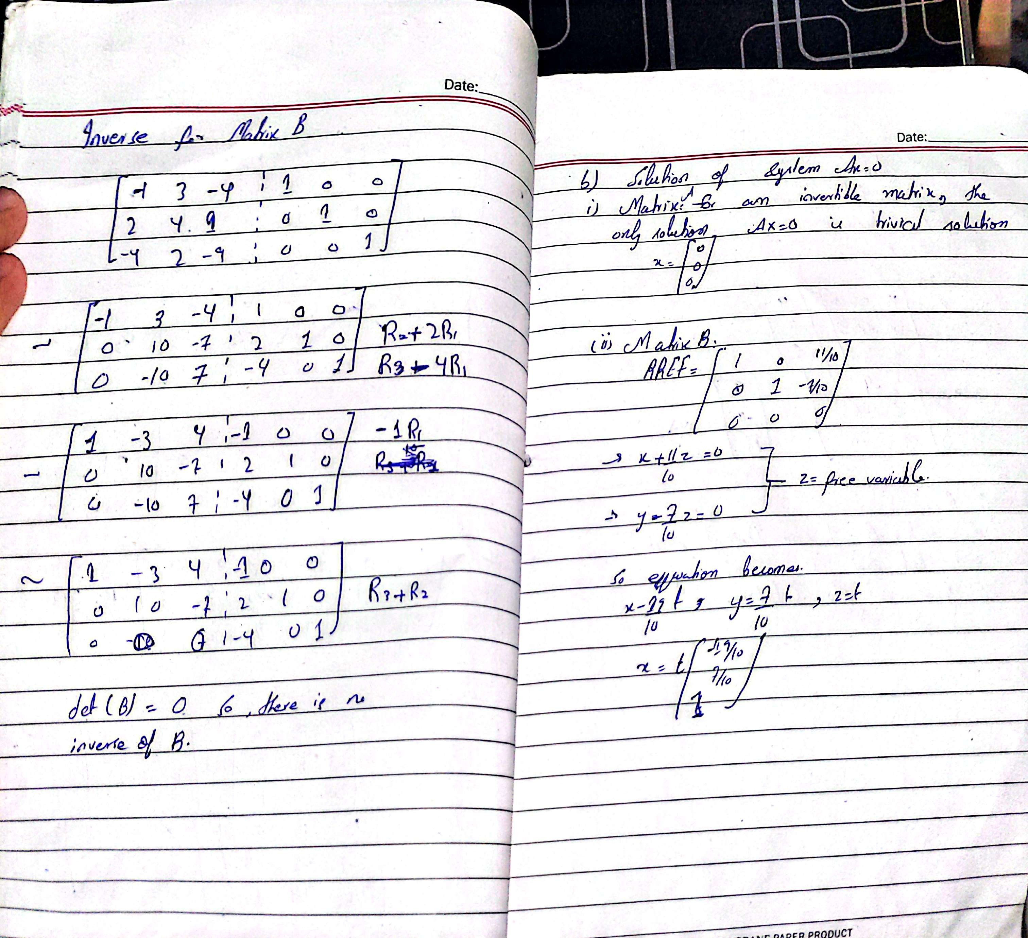

**Q no 10**

Code: import numpy as np

def gauss_jordan(A, B):

n = len(B)

A = A.astype(float)

B = B.astype(float)

aug = np.hstack([A, B.reshape(-1,1)])

for i in range(n):

aug[i] = aug[i] / aug[i, i]

for k in range(n):

if k != i:

aug[k] = aug[k] - aug[k, i] * aug[i]

return aug[:, -1]

def inverse_method(A, B):

A = np.array(A, float)

B = np.array(B, float)

invA = np.linalg.inv(A)

return invA.dot(B)

n = int(input("Enter number of equations: "))

A = []

for i in range(n):

row = list(map(float, input().split()))

A.append(row)

B = list(map(float, input().split()))

A = np.array(A, float)

B = np.array(B, float)

sol_gj = gauss_jordan(A, B)

print("Solution using Gauss-Jordan Method:")

for i, val in enumerate(sol_gj):

print(f"x{i+1} = {val:.4f}")

sol_inv = inverse_method(A, B)

print("\nSolution using Inverse Matrix Method:")

for i, val in enumerate(sol_inv):

print(f"x{i+1} = {val:.4f}")

**Output**

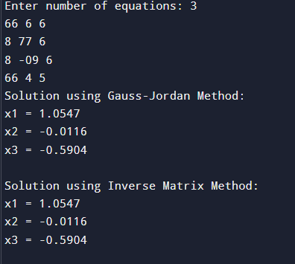

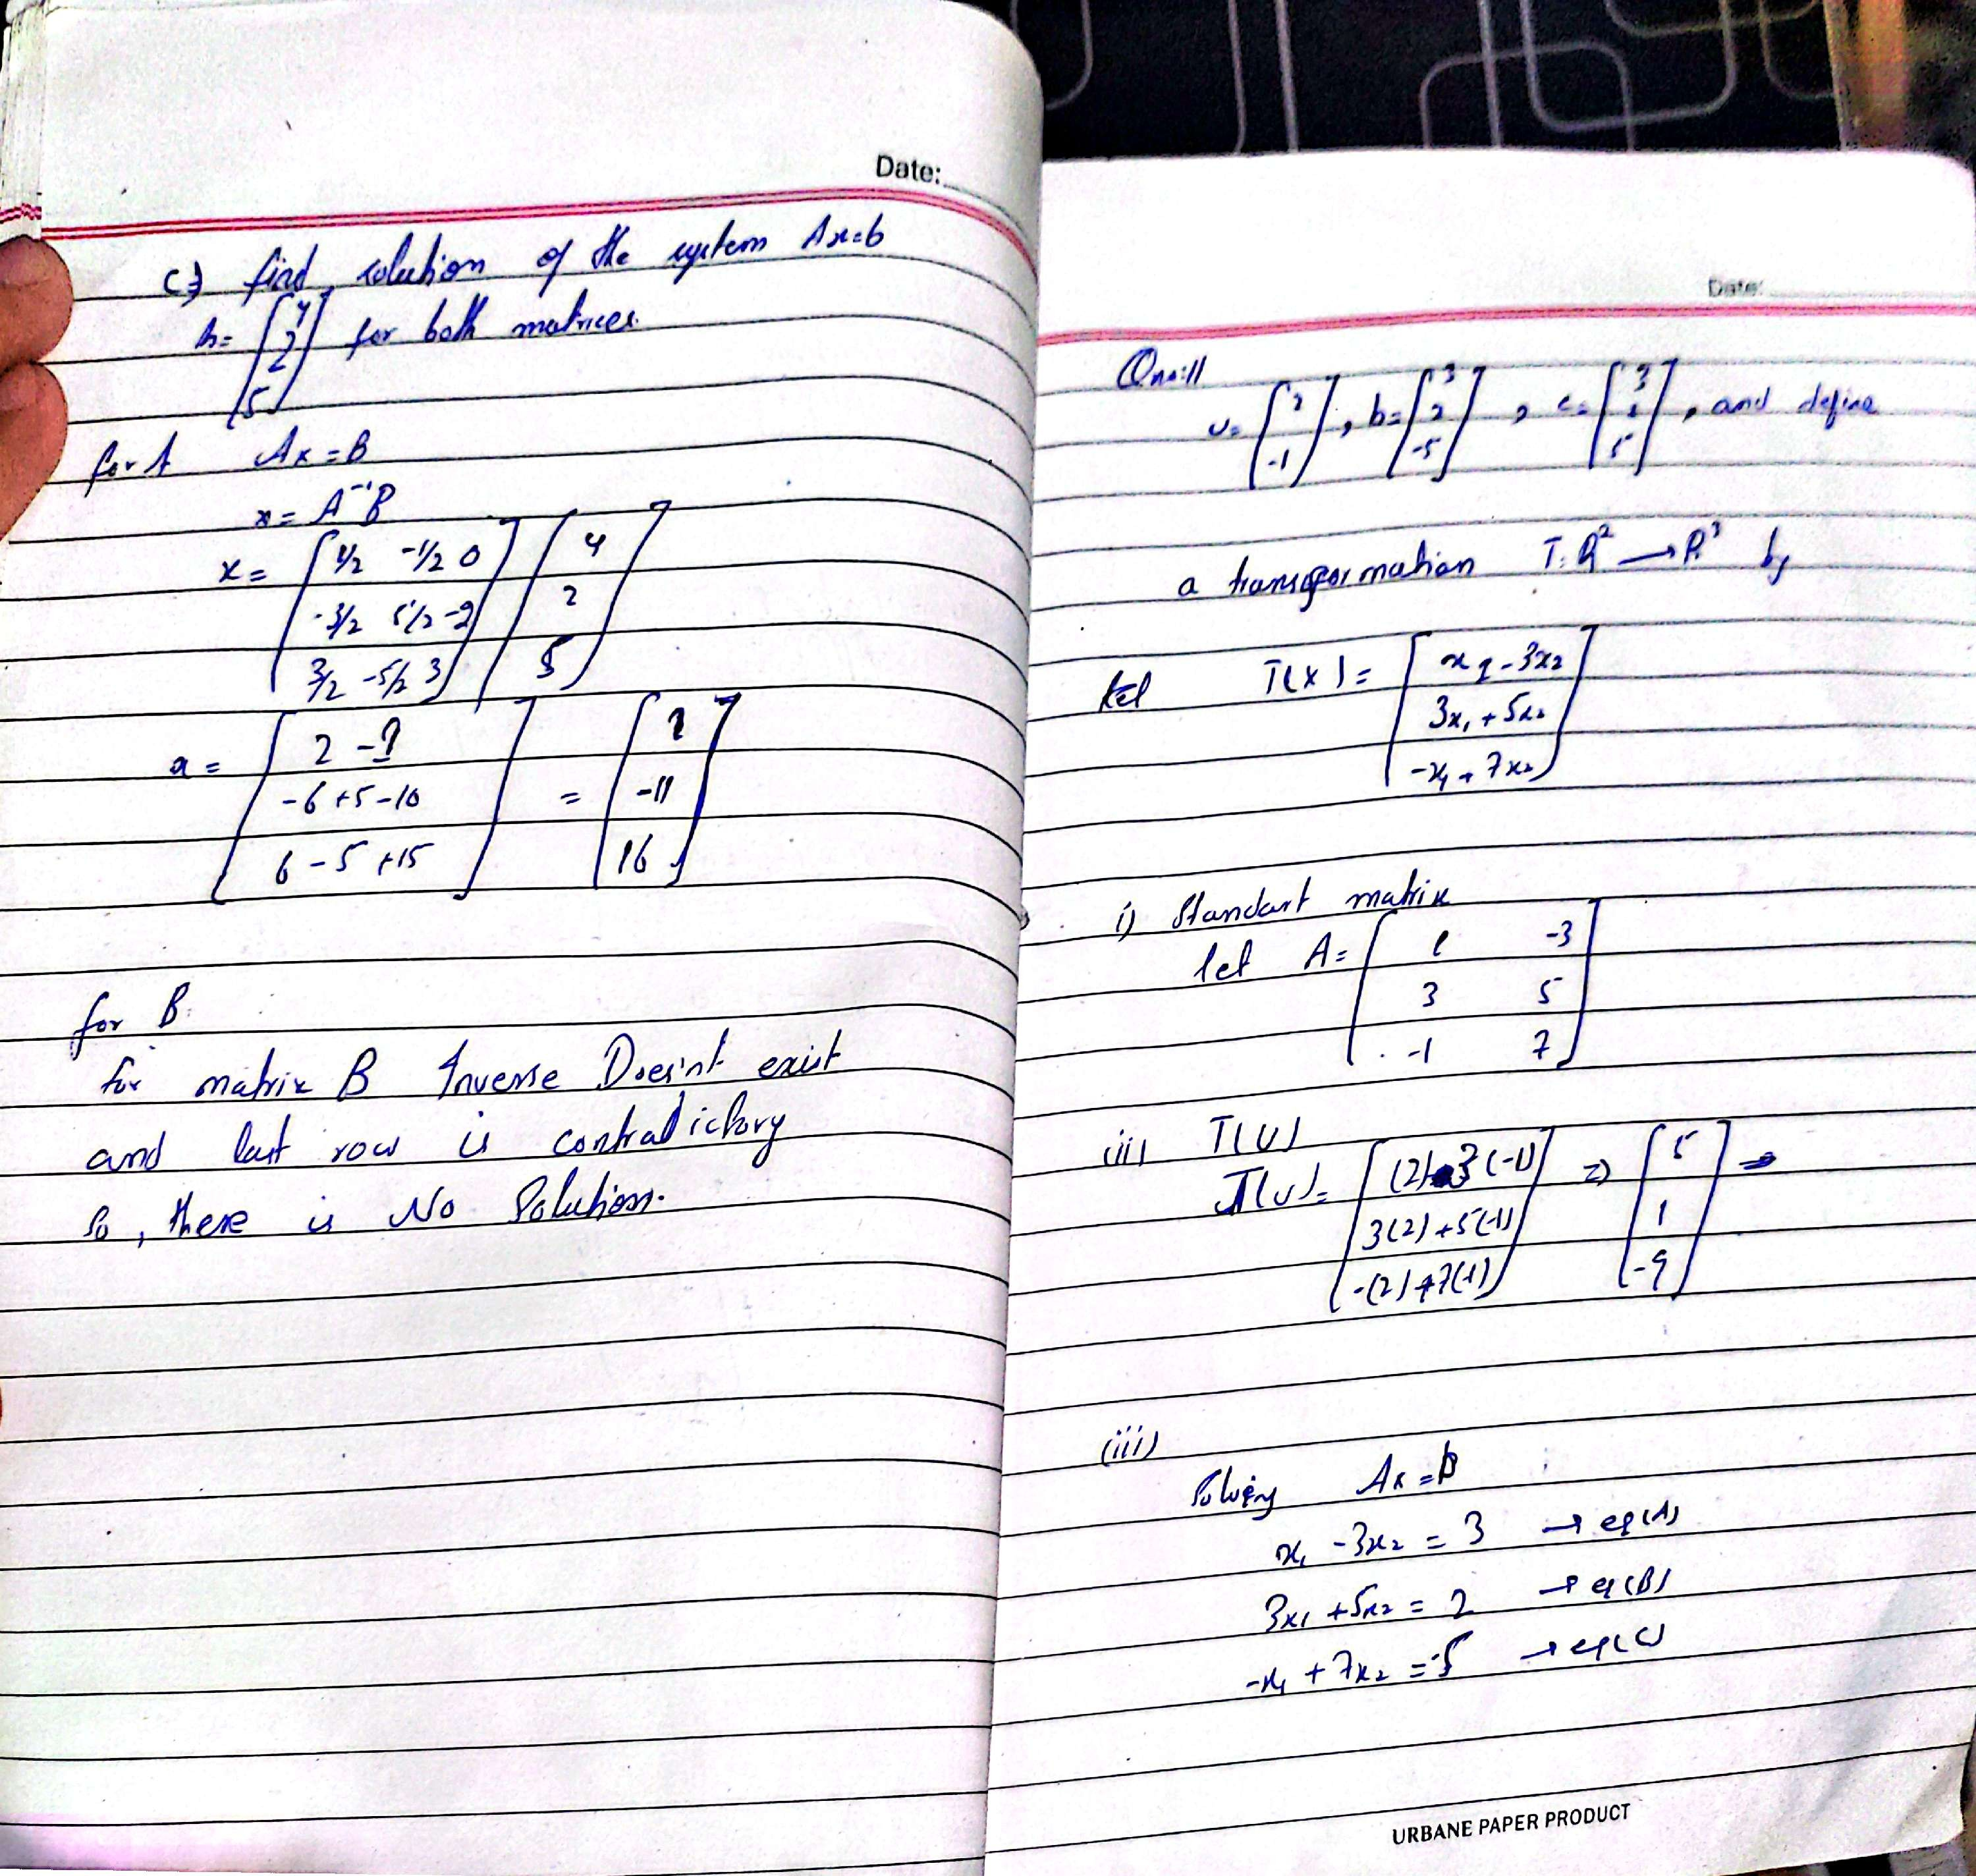

**= len(B)**

**A = A.astype(float)**

**B = B.astype(float)**

**aug = np.hstack([A, B.reshape(-1,1)])**

**for i in range(n):**

**aug[i] = aug[i] / aug[i, i]**

**for k in range(n):**

**if k != i:**

**aug[k] = aug[k] - aug[k, i] * aug[i]**

**return aug[:, -1]**

**def inverse_method(A, B):**

**A = np.array(A, float)**

**B = np.array(B, float)**

**invA = np.linalg.inv(A)**

**return invA.dot(B)**

**n = int(input("Enter number of equations: "))**

**A = []**

**for i in range(n):**

**row = list(map(float, input().split()))**

**A.append(row)**

**B = list(map(float, input().split()))**

**A = np.array(A, float)**

**B = np.array(B, float)**

**sol_gj = gauss_jordan(A, B)**

**print("Solution using Gauss-Jordan Method:")**

**for i, val in enumerate(sol_gj):**

**print(f"x{i+1} = {val:.4f}")**

**sol_inv = inverse_method(A, B)**

**print("\nSolution using Inverse Matrix Method:")**

**for i, val in enumerate(sol_inv):**

**print(f"x{i+1} = {val:.4f}")**

